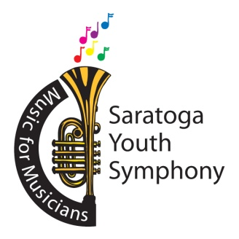
Joshua Thompson, Music Director
Sue Nazzaro, Executive Director
Ellen Madison, Marketing Director

Saratoga Youth Symphony Audition Application

Musician’s name Age Instrument

Name of parent or guardian Email address

Musician’s street address

City State Zip Code

Preferred telephone number to call

Name of private teacher Phone # and email of private music teacher

Name of school and school music teacher Email of school music teacher

List previous orchestral experience

Audition selection and composer – one piece or movement with contrasting passages

Audition Selection Composer

Parent/guardian signature Date

- A non-refundable audition fee of $40 must accompany this completed form
- Mail form with audition fee to: SYS Auditions, PO Box 3092, Saratoga Springs, NY 12866
- Make check payable to: Saratoga Youth Symphony
- You will be notified by telephone of your audition time and location
- Annual tuition: $500 per child

PO Box 3092 • Saratoga Springs, NY 12866
(518) 583-1128 • Saratogayouthsymphony@yahoo.com

